Module 2 – Schematics
This module introduces you to a new ‘graphical language’, which you can use to describe very complicated processes. You will learn to read the schematics and be introduced to computer-aided design (Visio, HYSYS) as tools to help draw schematics.
The module introduces 3 basic types of schematic representations for a chemical plant: the block flow diagram (BFD) and Process Flow Diagram (PFD) and Piping and Instrumentation Diagram (P&ID). The P&ID can be used to show how a plant is controlled, and so we will discuss this, then we will then apply your new symbolic lexicon to understand specific case studies in later modules.

Outline
Primary learning outcomes for the module:
- Develop an understanding of the 3 types of chemical engineering diagrams: Block Flow Diagrams (BFDs), Process Flow Diagrams (PFDs) and Piping and Instrumentation Diagrams (P&IDs)
- Develop an understanding of control logic including: control loop variables, direct and indirect control, cascade control, and equipment control schemes (for flow, level, temperature, and pressure).
- Design, analyse and describe control logic based on Piping and Instrumentation Diagrams

2.1 Diagrams Overview

2.1.1 Block Flow Diagram
The Block Flow Diagram (BFD) is the simplest schematic, and it would usually be associated with the earliest stages in a design process, such as the feasibility study stage. It shows major processing steps as square blocks, and it is what you draw in M&EB to help visualize a mass and energy balance. So, it would include reactors, separators, treatment but not individual pumps.
Block flow diagrams conventionally depict:
- Only show major equipment items (mixers, separators, reactors, heat exchangers)
- Shows as blocks (not symbols)
- Can group many units together
- Flow direction shown by arrows
- All straight lines (horizontal and vertical)
- Flow from left to right (where possible)
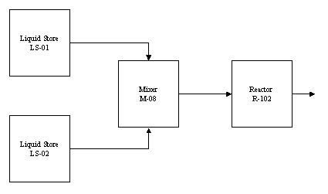
Below is shown a BFD for a mono-ethylene glycol synthesis process.
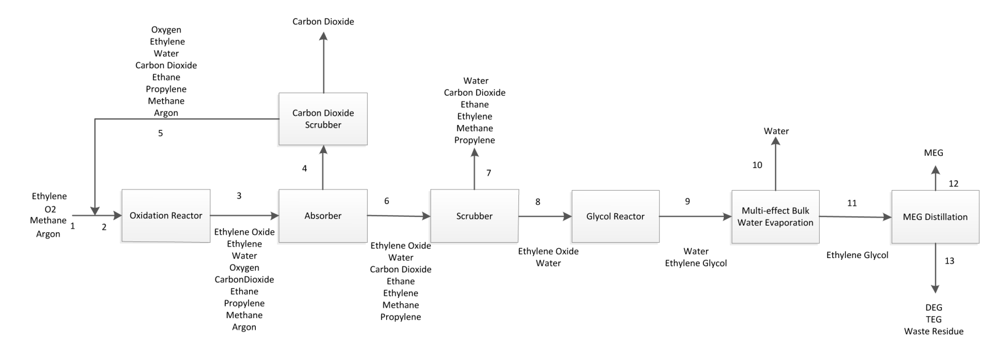

2.1.2 Process Flow Diagram
The Process Flow Diagram (PFD) is a diagram of the relationship between major equipment items and system components (but not more minor components like pipe schedule, control valves, measurement devices etc.). It is what you draw when you do a layout in HYSYS and it would usually be associated with the second major step in a design process, which is the Process Development Report (PDR).
Process Flow Diagrams conventionally depict:
- Process piping connections (but not diameter, thickness etc.)
- Major equipment symbols, names, and ID numbers
- Equipment items are shown as symbols, not blocks
- Valves that affect system operations
- Interconnection to other systems
- Major bypass and recirculation
- Operating values, maximum and minimum, temperature, pressure, and flowrate
- A PFD is accompanied with a table containing approximate stream compositions, temperature, and pressure
- Stream direction shown with arrows
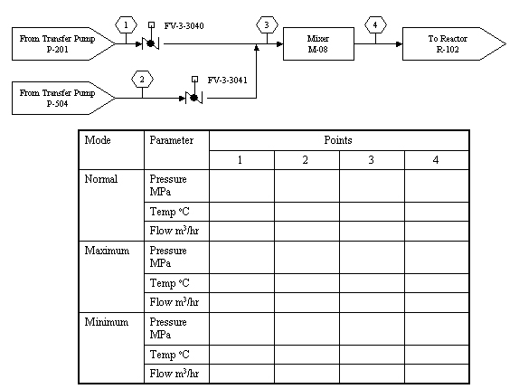

PDF template:
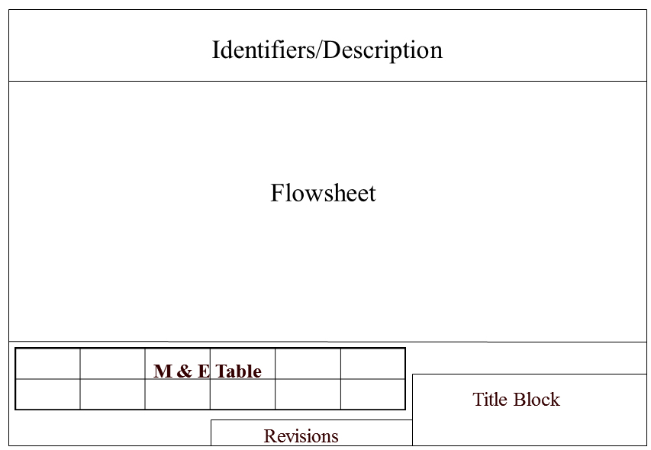
A PFD showing a process that converts ethylene to ethylene oxide is shown below
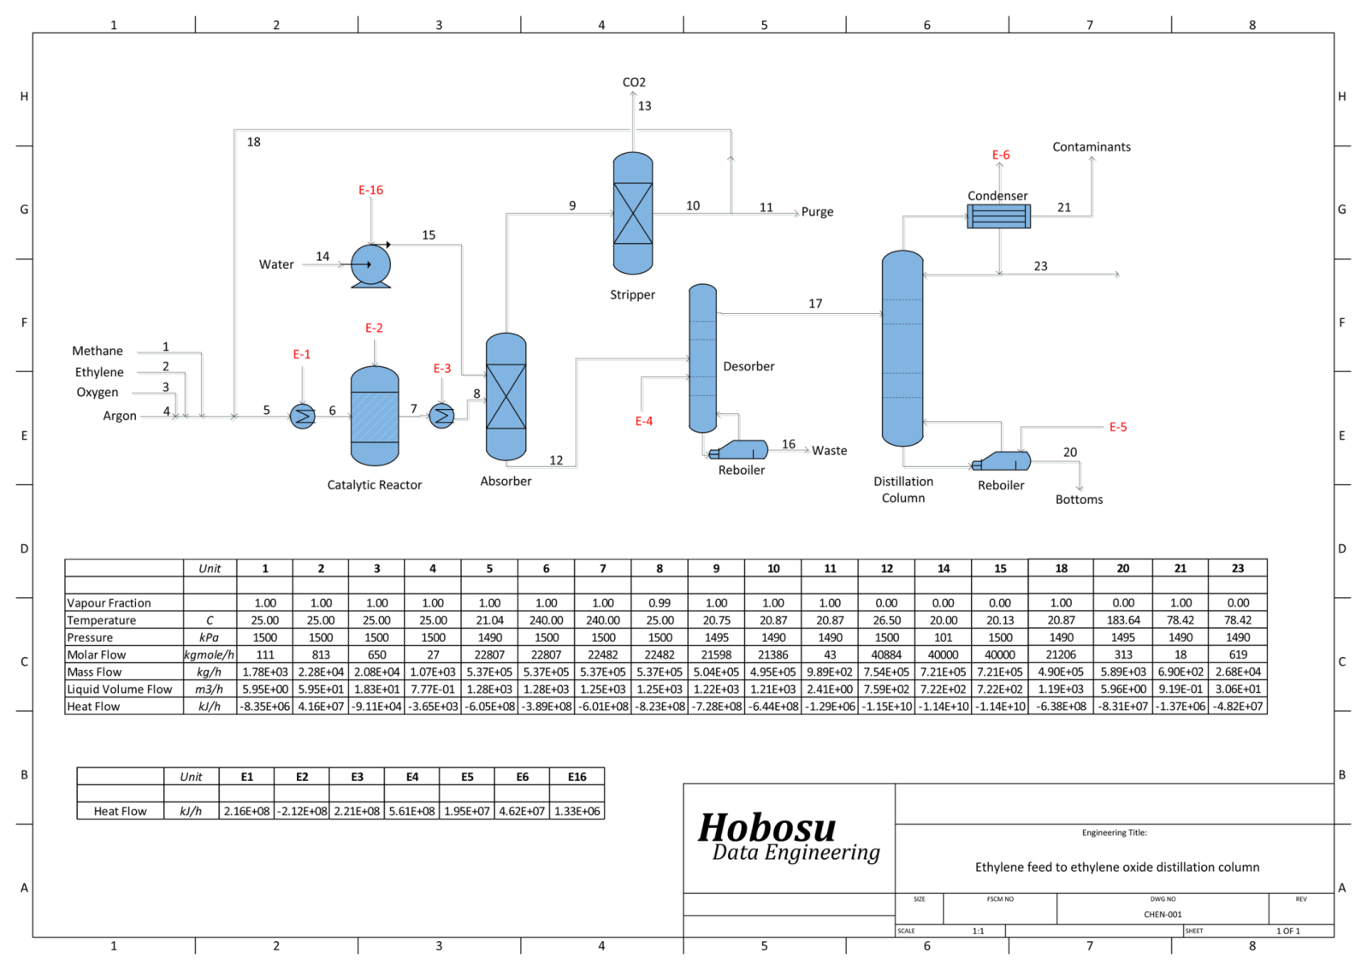

2.1.3 Piping and Instrumentation Diagram
The Piping and Instrumentation Diagram (P&ID) is the complete schematic of the plant. It is associated with the final stage of design, the Detailed Design Report (DDR) and gives the outline of all equipment, instrumentation, piping, and valves. If something is not shown on the P&ID, it will not be bought and included in the facility. So, it’s important everything is included. The P&ID will be designed over many, many iterations. Thousands of work hours may go into designing and refining it, and so the document itself can be worth hundreds of thousands of dollars. When designing the P&ID, you will need to think about more than just the everyday operation of the facility, but also start-up, shutdown (for routine maintenance every few years) and emergency operations. Given the size and complexity of the P&ID, it may be drawn across many schematic sheets.
The P&ID typically includes:
- All mechanical equipment with an equipment number
- All pipes with a line number, size, and identification
- Permanent start-up and flush lines
- Flow directions
- Pumps with code number (if applicable)
- Valves (control and block) with an identification number
- Ancillary fittings (such as steam traps, mixers, strainers) with identification numbers
- Control loops and instruments

A P&ID is shown below for a cryogenic distillation column. This is just an example to show the complexity and level of detail.
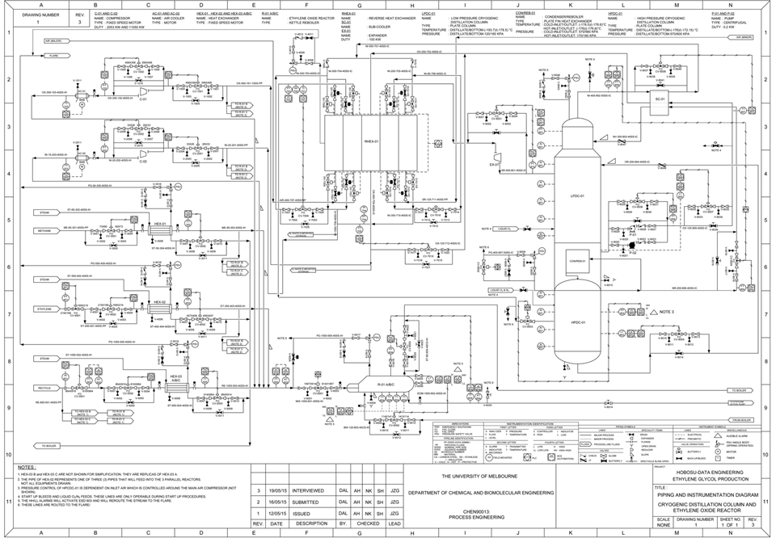
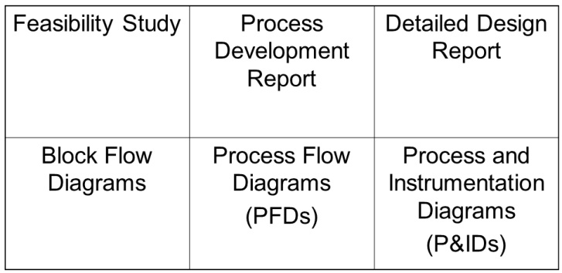
We outline the basic elements of a P&ID here but will apply them in later modules to discuss specific units.

Worked Example 2.1
LPG (Liquefied Petroleum Gas) may be extracted from crude oil by refining the light fractions. Typically, the process train would include the following basic units:
  - Pump (crude oil)
  - Atmospheric distillation column
      - Separate gas, light naphtha, heavy naphtha, kerosene, diesel oil, bottoms.
      - Condenser at top of column
      - Reboiler at bottom of column.
  - Gas processing unit
      - Separates Fuel gas from Butane
  - Butane undergoes Merox treatment
      - Mercaptan oxidation: Thiol (sulfhydryl) extracted using NaOH or NH₃
  - Compressor
  - Heat Exchanger/Cooler to liquefy to LPG

Draw a Block Flow Diagram (BFD) which includes all the relevant equipment items for a BFD from the dot points above.

2.2 Drawing Block Flow Diagrams
Drawing BFDs is focused on in Material and Energy Balances (CNEH20010), and so it will not be reintroduced in detail here. The key conventions to remember when drawing a BFD are:
- Units are collected into major processing steps and included in a single box
- All lines should be straight
- It should be drawn and read right-to-left
- It’s meant to convey information clearly and succinctly
For Fun Chem Eng, you will need to be able to read and draw a BFD, but usually as part of a larger, separate question. So, we use the diagram format as a tool (or a language) for discussing more specific problems within the subject.

2.3 Drawing Process Flow Diagrams
We will now go into detail into how to draw a PFD (with a primary focus on drawing in AutoCAD and Visio). It is the layout you see in the HYSYS simulation environment.

General advice for drawing PFDs (and P&IDs):
- Do rough sketch first
- Select appropriate icons for units
- Layout to reduce cross-over lines
- Do draft drawing
- Get someone else to check and sign off

All equipment items are designated with a code. For example, T-101 would refer to tank 101. These equipment codes are usually set by a company standard (there is no industry wide standard) but in general they’re designed to be simple; the first letter relates to the equipment item name and a number differentiates the equipment item from similar units on site.
T = tank R = reactor C = column
P = pump, M = mixer F = filter,
D = dryer HEX = heat exchanger
Q = furnace V = vaporizer G = gas movers

General rules for spatial layout of schematics:
- The schematic should be drawn to flow from left to right
- All major equipment items should be well-spaced to allow for easier reading
- The top section of the schematic is usually reserved for identifiers and descriptions
- The bottom section of the schematic usually has other information; engineering sign-offs and mass and energy table (in a PFD)
- Schematics have a border, title block, revision notes and space for all contributing engineers to sign-off
- Usually, utility lines are shown along the bottom of the drawing (for PFDs and P&IDs)
- Usually, vapor lines/vents are shown along the top of the drawing
There are a range of tools to draw schematics. The two most common you are likely to encounter in industry are Visio and AutoCAD (The CAD stands for Computer Aided Design). Within AutoCAD is an add on called Plant3D which is great for drawing P&IDs.
When drawing in Visio, you can select a template specifically for drawing PFD processes: File>New>Process Engineering> Process Flow Diagram (metric). You can also use the snap and glue function.
A PFD would usually be drawn on larger sized paper (A3 or above) and follow these general conventions in Visio:
- 1.2 mm (thick) for main flow streams
- mm (medium) for recycle streams
- 0.7 mm (medium) for secondary lines
- 0.4 mm (thin) for tertiary lines
- 0.5 mm (thin) for services
Make sure all fonts are readable (it’s common to accidentally produce them too small in the final drawing). A PFD has a table at the bottom that give basic material properties of all major flow and utility streams.
You will use identifier icons to connect streams between adjacent pages. You usually make sure these stream lines align between pages. When a stream connects between pages, we use an identifier icon (a hollow arrow) with a description of the stream to show it’s connecting to another page:
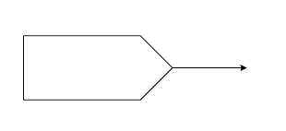

We also label all streams with number for identification (you can do this automatically in Visio).
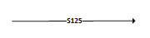

On a PFD, an arrow is usually shown on the stream line when it changes direction (i.e., makes a 90º turn).
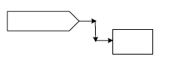

Control loops are not normally shown on a PFD, but pumps and other ancillary equipment are shown.

2.4 Drawing Piping and Instrumentation Diagrams

We will now move on to discuss the most detailed plant design schematic, the P&ID, which shows a detailed plant equipment layout as well as the control scheme (the automated processes included for safety and plant operation). We will begin by discussing the P&ID schematic and layout, then discuss common control arrangements.
Based on the P&ID:
- Mechanical and civil engineers will design and install pieces of equipment
- Instrument engineers will specify, install, and check control systems
- Piping engineers will develop plant layout and elevation drawings
- Project engineers will develop plant and construction schedules
- Hazard and Operability (HAZOP) studies will be conducted
- Operators will be trained
- Start-up/shutdown procedures will be developed
- Troubleshooting/debottlenecking and plant upgrades will be conducted.

So, the P&ID is an essential document. When the plant is being built, if a valve or other piece of kit is left off the P&ID, it will not be purchased and installed. Changes after the plant has been built come at an extremely high cost. Each PFD will require many P&IDs.
The P&ID is drawn to a set of international standards. Many large companies may have their own internal standards, for example after the Deepwater Horizon spill, BP updated and reviewed many of its internal design standards and is often considered best practice in the oil and gas industry.
International standards you may be required to design to (depending on location in the world, company you work for):
  - PIP: Process Industry Practices
  - ISA: Instrumentation Systems and Automation Society
  - ISO 10628: Diagrams for the Chemical and Petrochemical Industry (International Standard)
  - TEMA: Tubular Exchanger Manufacturers Association
  - OSHA: Occupational Safety & Health Administration

As the P&ID is so essential to the final design of the plant and its safe operation, the design of the P&ID is done by a team of engineers and goes through a range of review procedures to verify it is correct and facilitates safe operation.
- Revision A: General layout, based on PFD. Equipment details, piping, control & block valves, PSVs (pressure safety valves)
- Revision B: Line sizes, design conditions, miscellaneous equipment. Material selection, spec breaks.
- Revision C: Issue for Review. Update controls & instruments, preliminary elevations.
- Revision D: Issue for Preliminary Hazard Analysis
- Revision E: Issue for Design
- Rev F: Issue for HAZOP. HAZOP is a systematic process designed to review safe operation of the plant and review current safeguards around the plant. Update equipment, piping, instrument data during the HAZOP.
- Rev G: Incorporate HAZOP comments
- Rev 0 Issue for Construction. Collect final vendor bids & piping data.
- Rev 1 onwards: As Built. Field verification

2.5 Layout of your P&ID
General conventions and considerations for laying out a P&ID:
- Amount of detail. You need to balance information & clarity. You may need to split your P&ID across more sheets or condense sheets to ensure there is sufficient information and clarity on each page.
- Avoid clutter. Typically, a P&ID would have a maximum of 3-4 equipment items per sheet
- Allow for additions. This can mean leaving space in the design for more detail in later revisions. But in the design of the plant, we also want to consider future expansion of the facility and so it can also means designing with sufficient room to allow later additions to the plant.
- Typical details on separate sheets: Compressor Seal systems, Vendor P&IDs

The P&ID should be designed to follow the PFD sequence (in equipment ordering etc.). It shows the actual configurations of all units, which means the vessel orientation, a rough drawing of the internals of each of the units, where pipes connect to equipment items, flow paths within a heat exchanger, relative elevations (for example a pump near the bottom a unit, not near the top which would imply it was housed on a scaffold or platform).
Each project will have a specific legend sheet and title block that will be common across all P&ID drawings for the project (each sheet in the final design and in each version across all revisions).
The P&ID will be accompanied with a legend sheet that describes all the symbols used within the schematic. The legend should show:
  - Symbols for equipment, instrumentation, controls, piping items
  - Line numbering convention, insulation, or tracing symbology
  - Equipment and Instrument tagging conventions
  - Accepted abbreviations and other notes

Note: a symbol library for drawing P&IDs is available in Visio under Create -> Piping and Instrumentation Diagram (the same library is available if “Process Flow Diagram” is selected). The symbols available in Visio are not entirely standardised, as there is no complete standardisation across the industry. However, a common-sense approach should be used to identify and select the most appropriate symbol for any diagram.

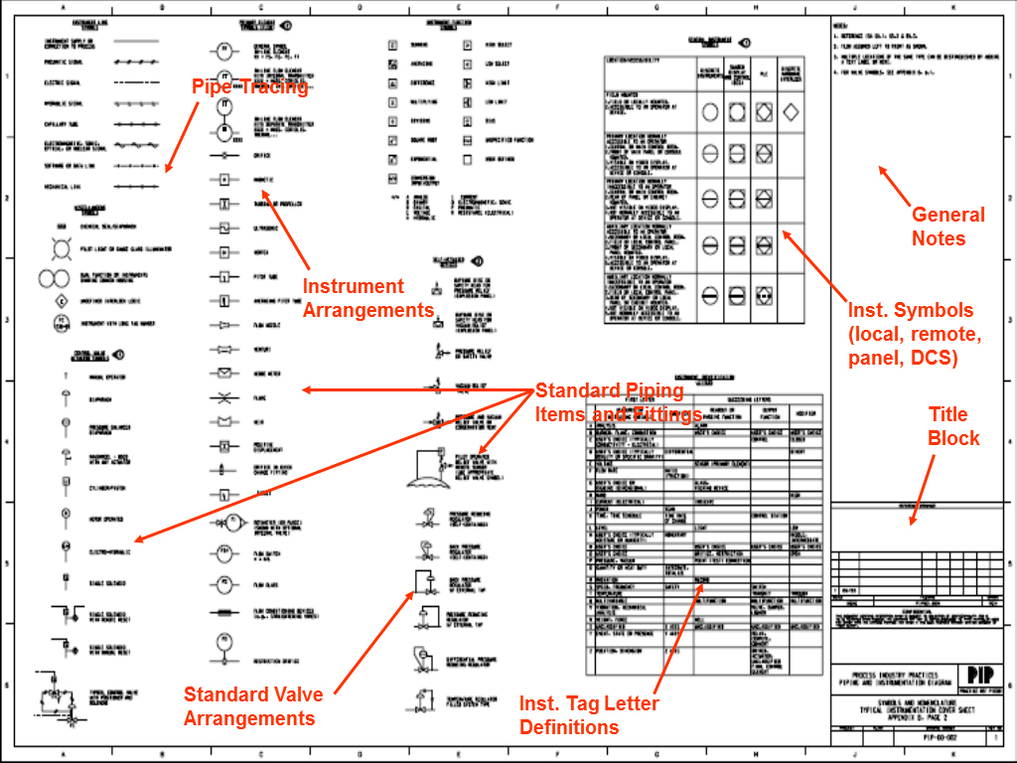
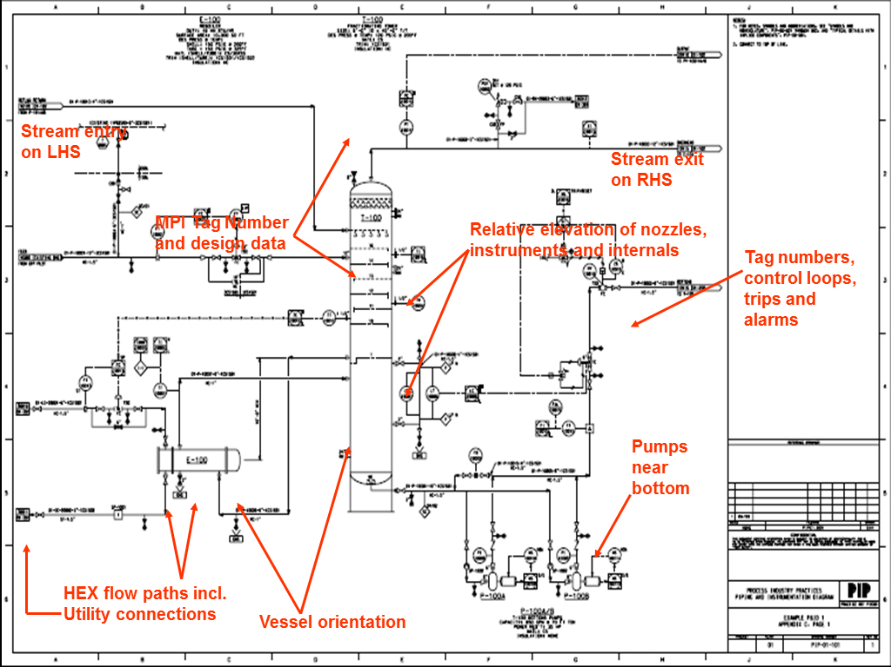

When drawing your P&ID, you need to consider more than just the normal steady state operation of the plant. The P&ID should also show vents and drains, lines for drawing samples as well as lines for purging, commissioning, start-up, shutdown, and off-spec product.
Process lines are normally drawn with a heavier weight, while utility lines usually have a lighter weight.
On the drawing, the line code should show the line size (pipe diameter), class, metallurgy (material of construction) and insulation on the pipe (if any). So, it might have a code like: Unit-Service-Number-Size-Class-Insulation (16-P-101-150-CS300-H) or Size-Service-Unit-Number-Class-Ins (150-P-16-101-CS300-H).
- 150: 150mm diameter pipe
- P: Signifies fluid service
- 16: Signifies the unit number
- 101: Would be the series number for the unit
- CS300: Carbon steel and the grade
- H: Insulation class (here H could mean hot in the legend)

When designing the piping, we need to consider slopes in the pipes to prevent liquid build up. A small wedge can be used to indicate a slope in the pipeline (it denotes the direction of the gradient).
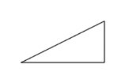
We want to avoid pockets in lines that can facilitate vapour or liquid build-up. We also need to consider whether material will be withdrawn from a vessel at the top or bottom. Liquid is usually drawn from the bottom of a vessel, and this may mean the base of the vessel needs to be sloped, with the draw point at the bottom of the slope, to prevent liquid accumulating around the edges.
When designing equipment and lines, we usually consider the maximum and minimum design pressure and temperature the system might experience, and design to these limits (considering contingencies and unusual operations). This then allows us to set the material of construction (different metals have different tensile strengths), establish breaks for connecting systems and identify isolation requirements (valves, check valves and isolation such as spectacle blinds).
Developing the P&ID will require you to identify all nozzles, internals of equipment items (trays, baffles, vortex breakers), dentate relative elevations, show approximate liquid levels within units in normal operation, show all safeguards and show spare units and parallel units (for example as pumps are usually relatively inexpensive, pumps are usually placed so that there are 2 in parallel; if one breaks down the second can automatically come into service while the first is repaired).
Sample graphical symbols for sifters, screen machines and sorting devices:
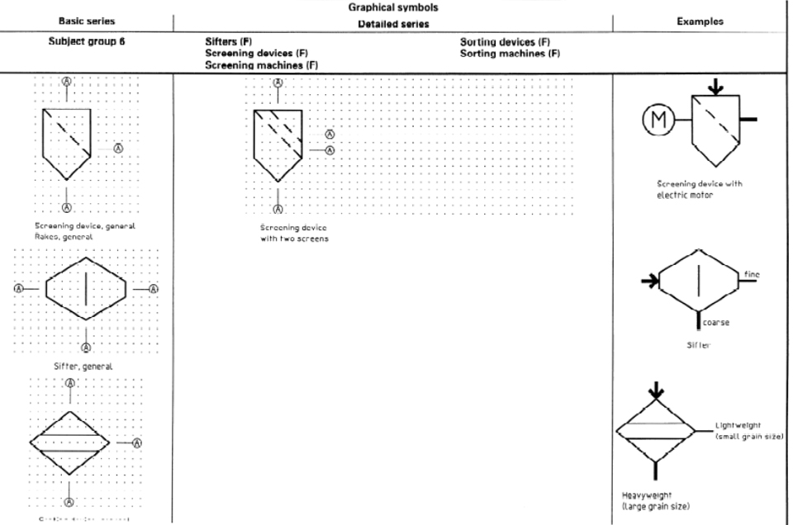

As you’re developing your P&ID, remember that the plant needs to operate in a whole range of modes beyond the normal steady-state operation you might have designed in your HYSYS simulation. You need to consider scenarios like:
- Testing and troubleshooting. For example, testing pressure, temperature and flow measurements as well as leaving sample points
- Start up, shutdown, upset conditions: Vents and drains
- Bypasses
- Equipment isolation and inspection: Purge gases and ‘double block and bleed’ lines around equipment and valves you want to isolate.
- Maintenance

The P&ID will show instrumentation for making stream measurements as well as the type of valves used for control. You need to decide if a piece of instrumentation will be used as an:
- Indicator. i.e., just to display the conditions.
- Recorder. Log all values either local or within a distributed control system (DCS)
- Controller. The output is used to modify something within the plant, such as a valve position
- Connected to an alarm, trip, or emergency shutdown (ESD)

The P&ID should also show valve types and whether the valves are fail open, fail closed or fail last position.
The P&ID would exclude information about the stream flowrates and operating conditions (for example temperature and pressure of lines). It is designed to be the document from which the plant can be built and so these types of considerations that are relevant in the design of the facility are much less relevant in the construction stage.
The P&ID also does not show equipment locations or pipe length. These are often fitted on site. The P&ID also doesn’t show supports, structures, or foundations, which may be designed by mechanical and civil engineers in separate drawings.
Things that would usually be considered when checking the P&ID:
- Consistency between P&IDs: Drawing connector blocks between sheets, making sure there is no duplication of equipment between sheets
- Consistency with engineering documents: i.e., making sure the P&ID still matches the PFD, equipment datasheets (for the individual equipment items), safeguard documentation.
- Speculation (spec) breaks: Double checking the design pressure and temperature are appropriate for the metallurgy and there is sufficient over-pressure protection (pressure safety valves (PSVs) etc.).
- Commissioning, start-up, shutdown requirements

2.6 Control Logics and Process Measurement
A piping and instrumentation diagram not only shows equipment, but also the control scheme for the equipment. By ‘control’ we mean the automated and manual equipment used to manage the plant for safe, quality, and economic operations. A valve may need to be opened to change a cooling water flowrate, to bring a reactor back to a design temperature. This means there needs to be a temperature sensor, to know the reactor temperature and a valve to change the water flowrate. Will these adjustments be made manually (by a person monitoring the temperature) or automatically (by a computer)? This information would be conveyed within the P&ID.

There’s usually no single ‘correct’ control scheme. There are usually a variety of different options that can achieve the goal but have competing advantages/disadvantages. So, it often helps to have a broad conversation about the over-arching objectives and priorities for control, then look at specific options.

In general, the function of process measurement and control is:
- Safe operation: to protect personnel and equipment by keeping process variables in a safe range and by responding to dangerous situations
- Production rate: To keep product being produced at the desired quantity and rate
- Product quality: Maintain product quality within required standards.
- Economic operation: Minimize waste, limit utility demand where possible.
If the plant is a water treatment facility, personnel safety controls may be less of a concern than a petrochemical plant, that handles large volumes of flammable material. If the facility is making food products for human consumption, then product quality may be more important than mineral tailings from an iron ore site (a waste stream primarily made up of unwanted dirt). So, the relative priority of these 4 criteria tends to shift depending on the specific context.

2.6.1 Basic Terminology

Direct vs Indirect Control
Direct measurement is when a parameter being measured is the parameter we want to know (e.g., reading the system temperature with a thermocouple).
Indirect measurement is when another variable is measured to infer a parameter we want to know. An example would be measuring temperature in a distillation column to infer composition. For example, a mixture of ethanol and water boils at different temperatures depending on the ratio of ethanol to water; measuring the boiling point can tell us the composition if we know only ethanol and water are present in the mixture. Measuring composition can be quite slow and the instrumentation is expensive, so we measure temperature instead, knowing that the boiling point of a mixture is a function of the composition.

Controlled Variable: The process variable to be controlled. This would be measured directly if possible.
Dependent Variable: A variable whose value depends on the controlled variable value. This would be measured if the controlled variable could not be measured directly (indirect control).
Set Point: The control scheme will try to maintain the controlled variable at its set-point; it is the value of the controlled variable that adjustments are made to try to keep constant.
Manipulated Variable: The property adjusted to keep the controlled variable at its set point.

Worked Example 2.2
A control scheme is designed to keep a reactor at a constant temperature of 50°C. The reactor contains an exothermic reaction, so the reactor temperature is modified by changing the flowrate of cooling water.
List the controlled variable, manipulated variable and set point of the control system.

2.6.2 Diagrammatic representation of process equipment in P&ID

Valves and control valves:
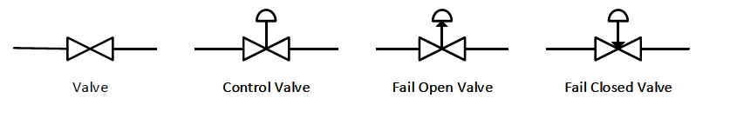

Location of the valve (is it operated at the site in the plant or remotely in a control room):
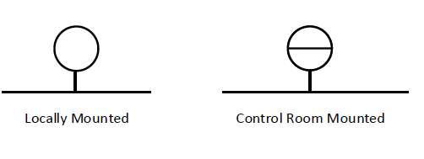

When displaying a control scheme, we would sequence letters to describe how the control works. The first letter usually indicates the parameter being measured. The second letter indicates the instrument function.

1st Letter Property | 2nd Letter Property
F: Flowrate | I: Indicator
P: Pressure | C: Controller
L: Level | R: Recorder
T: Temperature | A: Alarm
For example, a flowrate controller:
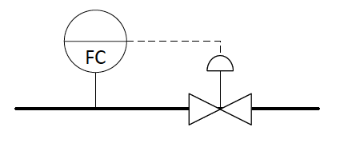
Flowrate is being measured and controlled (by the manipulated variable, a valve on the line).

Another example of a control scheme:
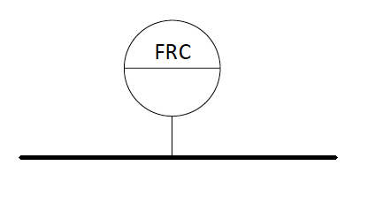
Flowrate recorded and controlled in a control room mounted panel.

We can also designate the type of signal being used for control. An electrical signal sends an electric current to drive an actuator (or motor) to turn a valve open or closed. If the valve is large or the fluid generates significant resistance, the actuator can be quite large and expensive. An alternative type of control signal is a pneumatic drive; here compressed air can be transferred through a line which connects to a diaphragm or piston at the point of the valve. Rather than having a large electric motor to drive the valve open or closed, changes in the line pressure can cause a pneumatic force to drive the valve open/closed (hence they can be cheaper and lighter in the event the valve is elevated).
A P&ID will show the type of control signal (electric vs pneumatic).

Electric signal (dashed line):

Pneumatic signal (hashed line). Pneumatic signals are very rare in new plants today because of the reduction in cost of electronic equipment (they are almost always lower cost now). But in case you see pneumatic signals in older P&IDs:
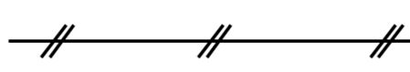

A table of common control signification is shown below.
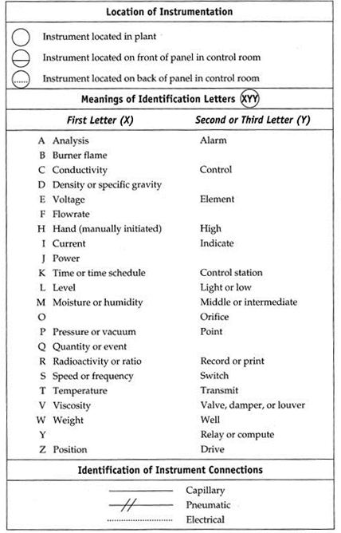

A variety of intermittent equipment items are required to complete a control operation. Say we want to control the outlet temperature of a stream from a heat exchanger by varying the flowrate of hot oil. A thermocouple is first used to measure the outlet stream temperature, this is then sent to a transmitter which converts the thermocouple signal into a measured value and transmits the information to the controller. The controller calculates the discrepancy between the measured temperature (from the transmitter) and the set point. If there is no discrepancy, it makes no adjustment. If the temperature is too low/high, the controller sends a signal to the valve actuator on the hot oil line to further open/close the hot oil valve.
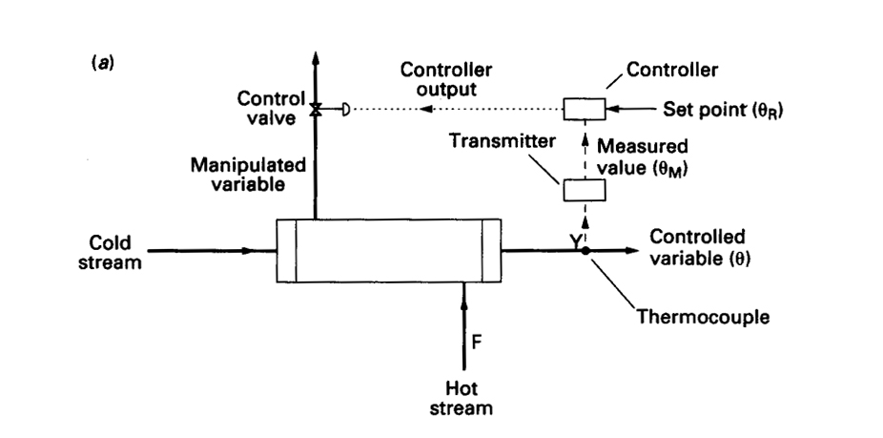
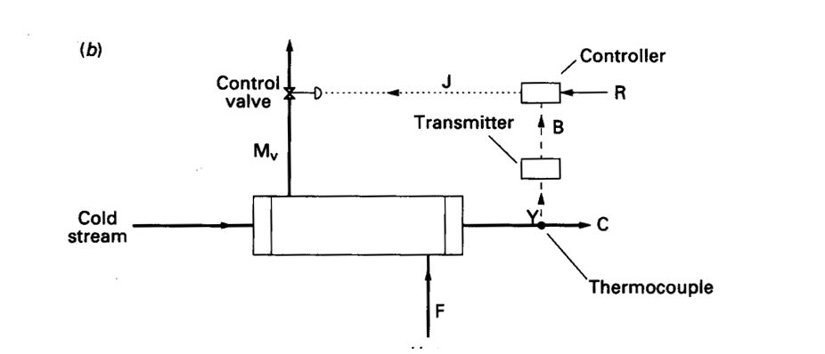

We will typically condense all these steps to just show the basic control logic (as shown below):
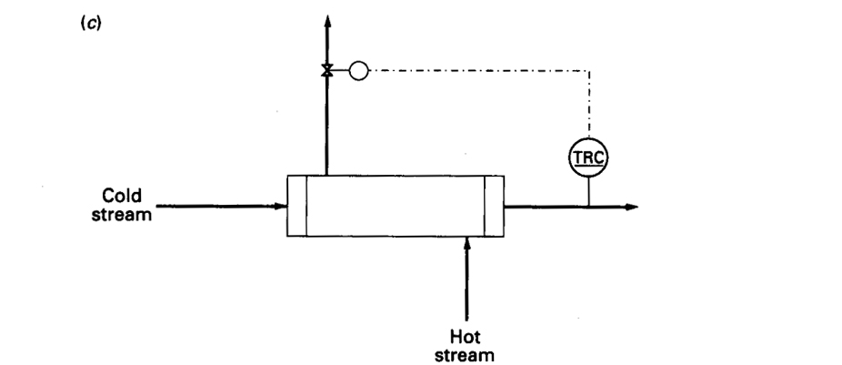

2.6.3 Multivariable control
Each controlled variable must be paired to a different manipulated variable. Two controlled variables cannot be paired to a single manipulated variable. One controlled variable is not usually paired to two manipulated variables over the same range of operations.
So, this raises a question about the possible control options.

Worked Example 2.3
Two water streams at different temperatures are being mixed. We would like to control the level of water in the tank and the final temperature of the tank. Like filling a bath to get it to the right level, we can change the flow rate of water to change the height and the ratio of cold:hot to change the final temperature.
How many ways of arranging the control pairings are available below given we have 2 sets of controlled-manipulated variable pairs?
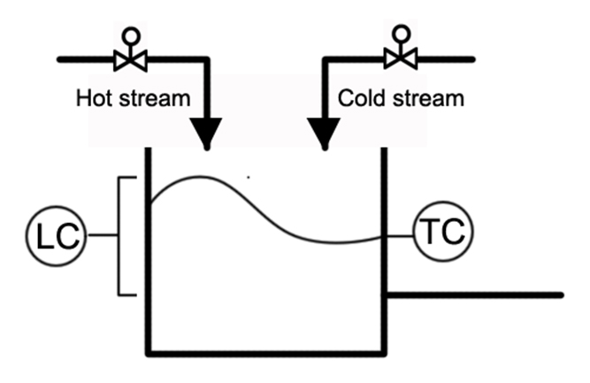

Worked Example 2.4
Like Worked Example 2.3, we now also want to control the flowrate of water out of the mixing unit. Although not all options may equally practical, how many different ways of arranging control scheme are available, when we have 3 pairs of controlled-manipulated variable pairs?
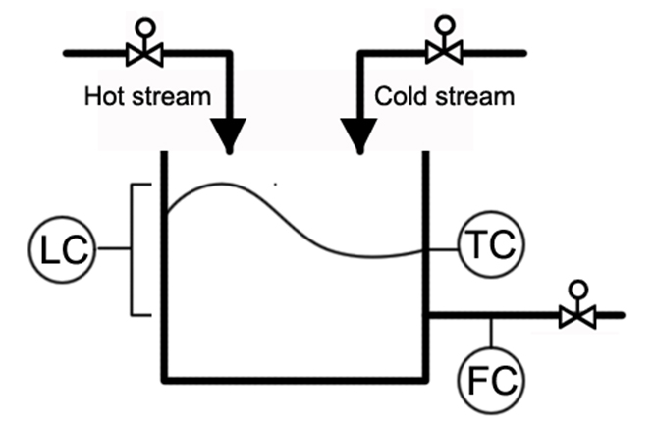

The key message from these two worked examples is that if there are N controlled-manipulated variable pairings, then there are N! control options. So, in reactors and distillation columns where there can be a high degree of interconnection and control pairings, the control schemes can get really complicated quickly; there can be a huge number of alternative control options to consider.

2.6.4 Typical Control Systems
Given the wide range of potential control pairings available, it makes sense that we discuss common sense control design; we usually want to pair a manipulated variable that will have a direct effect on the controlled variable.

Level Control
It makes sense to pair level in a tank to inlet or outlet flowrate from the tank. Clearly this would have a more direct effect on level than say the storage tank temperature.
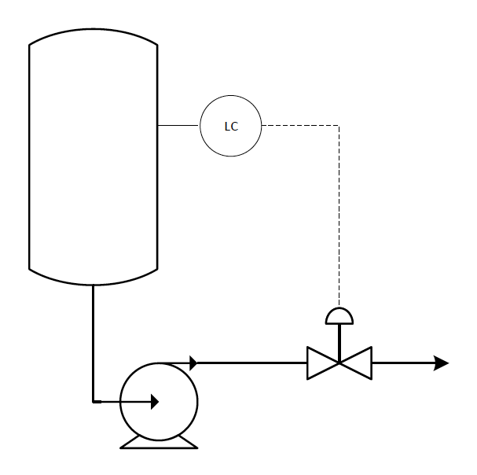

Pressure Control
Pressure control usually discussed in the context of gases; over most practical ranges liquids are usually considered incompressible. Using the ideal gas law equation of state, we can think about ways to control the pressure in a vessel.
PV = nRT
Controlling pressure usually means changing the number of moles in a vessel (by opening a valve to move material in or out or by controlling the reaction rate), by changing the temperature (cooling drops the system pressure for a given number of moles) or by changing the volume of the vessel itself (for example changing the liquid level in a 2-phase vessel or for a floating roof tank).

How might we draw pressure control systems in a P&ID:
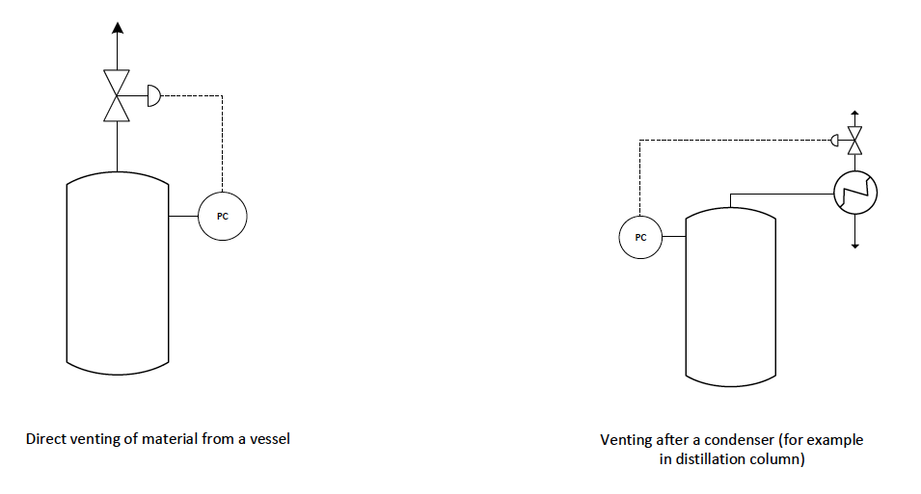

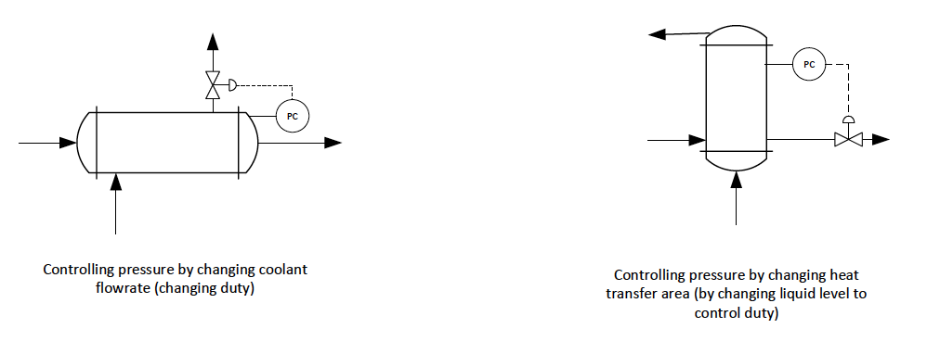

Flow / Pump Control
A common problem for pumps is called ‘surge’. Surge occurs when the flow in a line becomes unstable and begins to fluctuate; it creates an oscillating output pressure at the pump that can exceed the maximum pressure delivered by the pump and hence creates a reverse flow across the direction of the pump. Apart from damaging downstream equipment, flow reversal can shred the impellers of the pump itself (it’s considered really bad for the operation of a pump). Surge tends to onset at high output pressure but low flow conditions in a pump. There are a variety of ways to supress the effects of surge (for example, bursting disks that will rupture if the line exceeds a pre-set value, spring-loaded safety valves that mitigate the effects) but one of the simplest control mechanisms that causes no venting of product is a recycle line around the pump: the output side of the pump shown will be higher than the inlet side. Opening a recycle line from the pump outlet to inlet, allows backflow around the pump, back to the inlet and shifts the pumps location on a pump-curve (volumetric flowrate vs output pressure). As long as the pressure control loop can respond faster than the frequency of the oscillating surge pressure (typically on the order of 1 Hz) the control scheme can protect the pump.
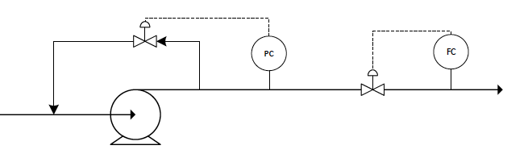
Once the pump delivers a stable output pressure, the flowrate can be controlled by shifting the position of a valve.

Cascade Control
In cascade control, the output of one controller is used to adjust the set point of another control loop. It is used to give smoother control in a situation where direct control would lead to unstable operation. Usually the outer loop (that adjusts the set point of the inner loop) is called the primary control loop (also called the “master” loop). The inner loop (that responds to the adjustments of the primary control loop) is called the secondary control loop (also called the “slave” control loop). For the cascade control to work effectively, the primary control loop should respond more slowly than the secondary loop; in this way, the secondary loop can implement changes dictated by the primary control loop before a new change is made.
For example, in the control loop below, the temperature of the distillation column sets the set point of the flowrate of the distillate stream (primary control loop). The flowrate of the distillate stream then adjusts a valve position on the reflux line based on its new set point (secondary control loop). Adjustments by the secondary control loop would happen over a very short time scale (on the order of 1 second). If the flowrate on the distillate stream is measured to be too high, the reflux control valve opens and so the flowrate of the distillate line quickly drops down. As the reflux flow rate increases it tends to drop the temperature of the column. But this change in column temperature might take 30 minutes to fully propagate through the column. After 30 minutes, when the column has reached a new condition, it might set a new set point for the secondary loop. So, this control loop tends to smooth out any perturbations in the system; the flowrate control on the distillate line can smooth out any short-term perturbations in product flowrate and over longer time scales the temperature (as an indirect measure of composition) can smooth out any perturbations in inlet conditions (that might affect the fractional purity of the 2 product lines).
Now imagine the timescales were reversed. If the secondary controller took 30 mins for a change to propagate and the primary control loop only took 1 second. The primary loop would issue new set points every 1 second, but the secondary loop would never be able to accommodate these changes (because it takes 30 mins for the change to propagate through the system). This control arrangement would tend to create artificial instability in the output; the primary control loop would keep issuing orders the secondary control loop could never fulfil, and so the secondary control loop would keep making radical adjustments to the valve position without ever coming to steady state operation.
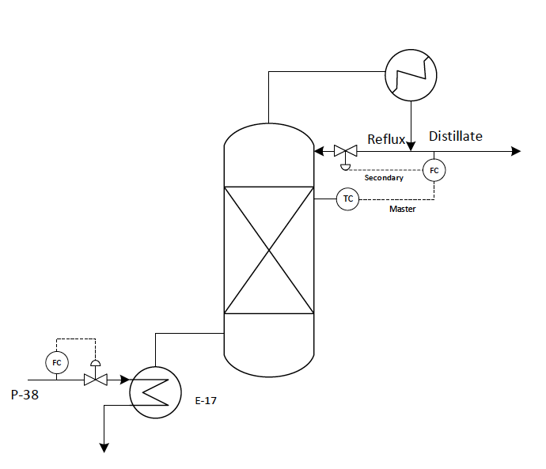

Ratio Control
Ratio control is designed to maintain two flows at a constant ratio (for example reactants in a specific stoichiometric ratio into a reactor). It would be an example of MISO control (multiple input, single output). MIMO, SIMO and MISO control arrangements are all possible, but they are rarely used. Control schemes are usually designed to be as simple as possible, which means the overwhelming majority of control pairings are SISO arrangements (Single Input, Single Output) as we’ve discussed so far.
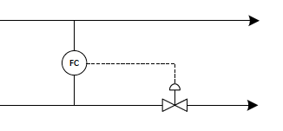

Worked Example 2.5
We want to design a control scheme for a continuous flow stirred tank reactor (as shown below). Reactants are charged into the reaction vessel continuously and mixed (by an agitator) and heated (from steam passing through heating coils). Product material is withdrawn constantly from the reactor.
Design a control scheme for the unit. (I have given the diagram twice so you can attempt it yourself in class and copy a solution we will go through together).
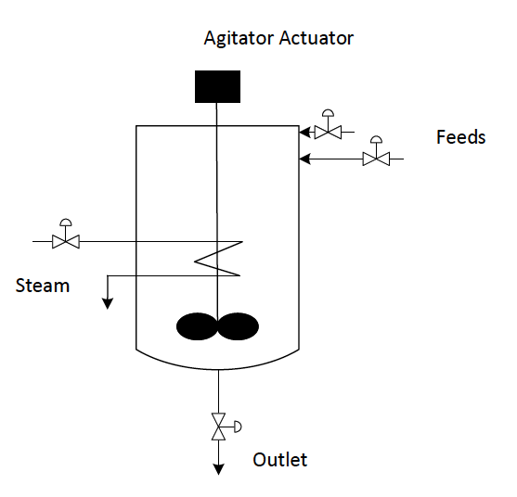



Safety Systems
The control shown on the P&ID needs to function to protect personnel on site and the equipment itself. So, process measurement will often be used to trigger safety systems built into the design, which can include:
- Alarms (visible and audio). An alarm must be associated with an operator action; they should not be included just for ‘information’ (which would be the function of an indicator). When drawing P&IDs, it’s easy to get carried away and just alarms on everything, but you need to consider what action the alarm will require (for example evacuation, emergency operation procedures or something else). Redundant alarms should always be removed from a control scheme; they can foster an onsite culture that alarms can be ignored. You also need to leave time for operator response: 10-30 minutes minimum on an alarm.
- Safety trips. Safety trips are an automated control action that does not require operator input. They would be included when a delayed decision could be dangerous. So, examples would usually be associated with an emergency operation (for example emergency venting to prevent rupture). Safety trips would often cause shutdown operations: e.g., pumps trips that shut them down, closing feed valves, opening purge valves etc.
- Interlocks. Interlocks usually prevent an operation from proceeding if another operation has not completed. For example, most elevators are fitted with a mechanical interlock: the elevator cannot move if the door has not closed. Another example would be a microwave over: the microwave cannot turn on if the door registers as open because of a mechanical interlock designed into the oven.
- Pressure control. Control should be implemented around vessel to prevent pressure build up, but in the event of unusual operation, most vessels will be fitted with pressure safety valves (PSVs) or rupture disks (sometimes called bursting disks). In the event that the pressure builds up to unsafe levels, the PSVs or rupture disks are designed to trip first (before the pressure reaches the design pressure of the vessel) so the pressure can be relieved in vent lines. This protects the equipment itself (from mechanical rupture) but also ensures material is vented safely (away from personnel on site and to a flare in the case of flammable or toxic material).

Simple control is usually good control
If you’re drawing a control scheme on a P&ID, a common student mistake is to overdesign the control. A general rule in control is to use the simplest control scheme that will accomplish the job; it makes the plant operation easier to understand, particularly when something goes wrong. In the event of unusual or emergency operation there are usually many possible causes that may be affecting normal operation; simpler control can often help diagnose the possible problem.

Worked Example 2.6
Draw a sample control scheme for a still (shown below). By fermenting sugars in water, we can produce alcohol. The still is designed to concentrate the alcohol from the water-alcohol mix after fermentation. We want to produce an alcohol rich steam with a fractional purity >70%.
You may assume an online analyser takes 15 minutes to measure composition. Thermocouples, level indicators, flowrate and pressure can all effectively be measured instantaneously.
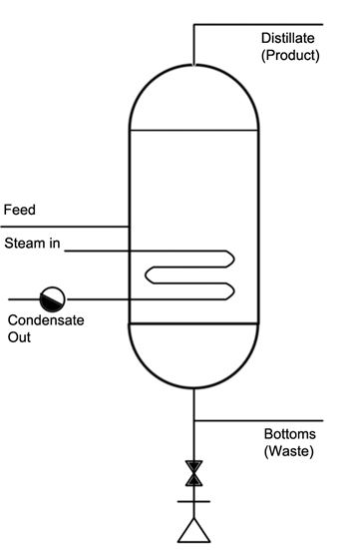


Module 2 Summary:

Key Points:
- Block Flow Diagrams (BFDs) are the simplest diagrams
- Process Flow Diagrams (PFDs) show large and intermediate pieces of equipment, as well as stream tables
- Piping and Instrumentation Diagrams (P&IDs) show every piece of equipment, as well as control loops
- Control logic:
  - Controlled Variable
  - Dependent Variable
  - Set Point
  - Manipulated Variable
  - Direct Vs. Indirect Control
  - Cascade Control
  - Equipment Control Schemes
- Safety Systems

Key Skills:
- Drawing BFDs
- Identifying controlled, dependent and manipulated variable in a control scheme
- Understanding and designing control schemes for basic equipment items

